**Recovery of Restaurant Businesses During Covid-19**

**1.0 Introduction**

**1.1 Intro & objective of document**

Due to the outbreak of Covid-19, many traditional businesses have been affected as potential customers were told by the government to stay at home in order to reduce the spread of this deadly virus. As a result, businesses have suffered from many great losses and are forced to reassess their working systems as soon as possible to reduce the losses and start covering them by earning profit.

**1.2 Team Structure**

The team consists of 5 group members including -- *Kenneth Yap Jing Min, E Hui Yun, Brian Bong Nyit Chiung, Esther Ann and Lim Kuang Weng*. **Kenneth Yap**, the leader of the group, was in charge of assigning duties to the teammates. As for the content of the report, he was in charge of the introduction, 1 of the solutions of the report and also compiling everyone’s work and highlighting the main points. Whereas the other 3 solutions were completed by Esther Ann, Lim Kuang Weng and E Hui Yun. While **Esther** was tasked with the solution, business-data analytics, compiling everyone’s work and highlighting the main points, **Kuang Weng** was assigned with the solution, improving delivery services and adding statistics and pictures whereas **Hui Yun** has written on following Standard Operating Procedures (SOPs) and adding statistics and pictures. Meanwhile, **Brian Bong** was assigned with problem statements, architectural overview and technologies and also referencing our sources.

**1.3 Background of Restaurant**

Restaurant businesses have been operating for as long as we could remember. After several years of hard work and perseverance, many restaurants have amassed huge reputations around delicious and eye-catching food. As most restaurants open early and almost daily, chefs prep the ingredients before they open. Staff members also clean the restaurant every morning and arrange everything to make sure everything is in place. Besides that, all cooking utensils and ingredients are also prepared early to ensure customers receive a quick, yet enjoyable service with full stomachs and satisfied faces from the best meals experience possibly offered.

**2.0 Problem Statement**

**2.1 Existing Problems in Traditional Restaurants**

One of the problems that commonly exists among traditional restaurants is that they cannot come up with a unique selling point. In this oversaturated industry, restaurant owners who do not have a clear mind of what their targets are mostly fail. They are facing these problems because of their lack of analytical skills on trends and customer preference. This can lead to further problems such as money loss due to wastage of ingredients as certain foods are not favoured by customers.

Moreover, traditional restaurants do not utilize automation enough, especially online. While modern restaurants are using online ordering systems, they are reaching customers that traditional restaurants cannot. The lack of automation also makes things more complicated. This costs traditional restaurants time, money and manpower.

People nowadays are realistic as they will go to whoever offers the most benefits. This is the exact reason why it is difficult to keep customer’s loyalty today. When competing with modern restaurants, traditional restaurants usually do not put in effort in loyalty programs (discounts, vouchers, reward points) and advertisement. All these put traditional restaurants on the downside.

**2.2 New challenges created by COVID-19 pandemic**

Due to the pandemic, the government has set standard operating procedures (SOP). This includes social distancing and wearing masks and check ins. Restaurants who fail to follow would be fined and forced to shut down. This also limits the number of working employees in the restaurant, making things more complicated.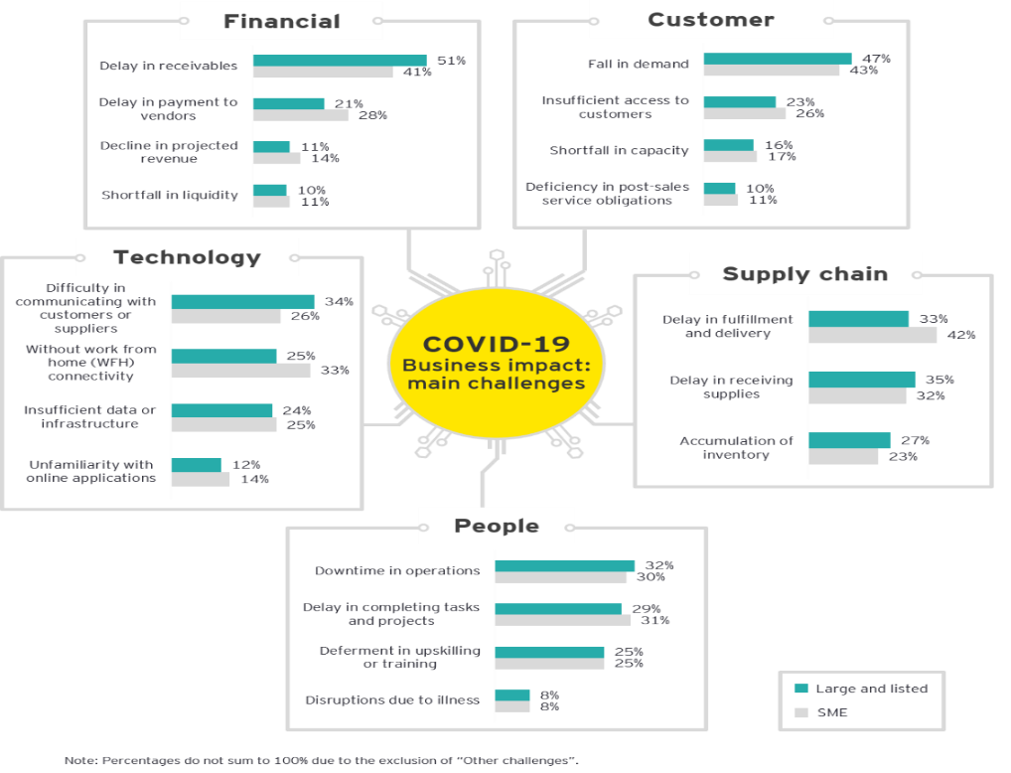

Furthermore, restaurants’ sales decrease as people are advised to stay at home to prevent the spread of COVID-19. This has caused people to cook at home more often. People would rather not go out and buy food knowing that they are at risk of being exposed to the coronavirus.

*Diagram 1: Challenges created by Covid-19 Pandemic*

Other than that, customers do not like to wait for food, especially in fast-paced cities. They would prefer to use their time on something more meaningful. For traditional businesses that do not provide online ordering services, customers would need to go to the restaurant to order and wait until their food is ready.

**3.0 Solutions**

**3.1 How Applications Work & Its Originality**

During the Covid-19 pandemic everyone is advised to stay at home. This has resulted in restaurants having to close down and avoiding people from dining in. The first solution to this is by enhancing delivery services of restaurants. Restaurants should do so by including other delivery services like Grab and FoodPanda services. Restaurants can also make their own delivery app or team up with food delivery companies. This application acts as a substitute to dine-in restaurants during the pandemic as customers can just order from delivery apps from their home. The app should also include contactless payment such as E-wallet, online banking or credit card to avoid any contact between the delivery staff members and the customers. Besides that, restaurants should share their contact number to customers in need of additional information. 

*Diagram 2: FoodPanda Driver Delivery Food*



The application relies on existing technology as downloading delivery apps and ordering from home is a common practice done by many households. For contactless payment the app should limit the price of the food for online payment. This is to avoid any transaction error and avoid the customer from overpaying. Customers can also access the app anytime and pre-order food using the application. The delivery app consists of a chat box for the customer’s enquiry.

*Diagram 3: Delivery Application*

One way of reforming the restaurant business and putting it back on track is by creating its individual mobile app. This in turn can help the restaurant gain recognition. Also, customers will be notified of monthly promotions from selected dishes from the menu. Besides that, coupons can be given out to customers for use during the empty hours to fill in business. In addition, customer loyalty promotions are an excellent way to keep regular customers attracted to the business. These features will allow more transparency on the constant updates of the menu and keep customers hooked to the dishes. Thus, customers can easily access information on the ongoing changes of the restaurant without having to be physically present.

This app relies completely on an existing concept. Ever since the pandemic, digital orders have been the latest trend as customers can order food with just a few taps on their phones without having any physical contact. Besides that, they can reap the benefits of endless discounts and promotions. As a fact, Yum Brands, which operates KFC, Pizza Hut, Taco Bell and more had its global digital sales rise by $1B in the 2nd quarter of 2020. As such, other restaurants are turning to creating their own mobile apps and benefiting from the mass of online customers.

One of the solutions include having good business data analytics as it acts as a crucial navigation aid. This solution helps traditional businesses face challenges caused by Covid-19 as it helps in forecasting demand, anticipating possible supply chain disruptions and measuring the success of crisis intervention tactics which are just a few of the pressing crises faced by traditional businesses during this pandemic. Business data analytics have the ability to give businesses insights of the future and provide tons of information about their customers. Thus, it is essential as businesses must maintain customer satisfaction while dealing with budget cuts and lower spending projections due to the pandemic.

This solution is partly innovative but still relies on an existing concept. Though the methodology of business data analytics is built on a foundation of data that is reinforced by someone who has evaluated the data in light of the present economy, the objective is to introduce artificial intelligence into business data analytics.

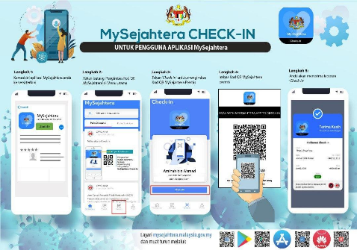Furthermore, when restaurants are allowed to be opened, Standard Operating Procedures (SOPs) need to be followed. One of the ways to make sure that our customers are safe from the virus is by implementing proper management planning. For instance, we could keep track of when customers leave and enter. This can be done by using applications such as the MySejahtera app. This app can track citizens’ whereabouts when they scan QR codes in various locations to make sure they were not in close vicinity to those infected with the virus. Also, when restaurant businesses begin opening up, the infection of the covid-19 can be reduced by implementing digital menus.

*Diagram 4: My Sejahtera Check-In Steps*

This application completely relies on an existing concept as these solutions are standard procedures suggested by the government and must be followed by every restaurant business. Besides that, it has been a year since the pandemic and citizens should have already adapted to these customs.

**4.0 Impact of Solutions**

**4.1 Impact on Traditional Business & Effectiveness**

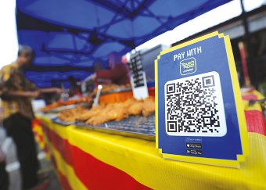The solution has a great impact on the traditional business such as the popularity of the restaurant will increase due to the availability of delivery services. Therefore, the income of the restaurant will also increase. Moreover, the restaurant can branch out to new methods of serving customers. Besides that, restaurants will rely more on technology and application of the restaurant. Restaurant owners will not spend as much on hiring more waiters/waitresses. Lastly, accepting E-wallet or credit card payments especially from customers using delivery services can help restaurants adapt to an easier money management system.

*Diagram 5: Touch’n Go eWallet QR code*

The delivery services are effective. Restaurants will not require many staffs to avoid overcrowding during the pandemic. It is also crucial for maintaining the safety, health and in easing the stress of the staff members. This solution can also be further utilised after the pandemic. For instance, customers can also order from the delivery app and dine from the comfort of their home as the option is available.

As for the traditional restaurant businesses, transitioning to a more online oriented business can bring the business closer to m-commerce. As the industry continues, restaurants would have to find more innovative ways to operate as customers desire simpler and more efficient ways to order, pay and collect. As such, this app can help the restaurant handle orders more efficiently while increasing productivity. This can be achieved even with less staff as there is no one present to serve. Moreover, the restaurant can operate with lesser running costs as customers may only visit to collect their orders.

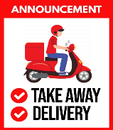

With customers unable to dine-in, they are unable to experience the typical restaurant atmosphere. However, restaurant mobile apps can compensate for the losses by improving the efficiency of the transaction process. Although eating at home does not provide the same restaurant experience, at least for the moment, customers can enjoy the gourmet offered by restaurants with delivery services from the comfort of their home.

*Diagram 6: Announcement Release when unable to dine in*

Having good business data analytics can help in anticipating customer needs. For instance, acquiring and understanding customer’s demands will be way easier. By doing so, the restaurant does not need to squander their expenses targeting every market. Furthermore, having good business data analytics reduces the possibility of risks and frauds faced. This is done by carrying out security and fraud analytics. Potential frauds can be detected immediately as well as identifying culprits and predicting future behaviours.

*Diagram 7: Implementing data analytics*

Good business data analytics can also affect the restaurant’s service by a tremendous amount. By implementing data analytics, it is easier to interact with the customers based on their personality and attitudes. This helps in delivering more personalized ads to customers which are more likely to grab their attention. Moreover, good business data analytics can also optimize and improve customer experience. This can be done by applying analytics during the designing and operation management process. Consequently, it will impact a business’ efficiency to attain customer satisfaction.

On the other hand, customers will feel safer when entering the restaurant compound. In this time and age, people are worried about the coronavirus and are following the SOPs to avoid getting infected. As such, having a restaurant with a safer system which decreases or completely prevents physical contact can put the customers at ease. Moreover, this gains customer’s confidence in the restaurant as it shows that it has made sufficient preparations to operate while prioritizing the safety of its customers.

This application is very effective as a single customer experience is sufficient for customers to make their judgement, whether it's accounting the food, atmosphere or service. When a restaurant follows these precautions, customers will decide on returning as they feel safe ordering or dining in the restaurant. Also, this will garner more loyal customers as the restaurant continues to accommodate customers with good service. Even when the pandemic ends, customers will remember the experience from the same restaurant and return even more as the restrictions are lifted.

**5.0 Business Viability Applications**

**5.1 Viability & Relevance of Applications**

The technicality of the delivery app provides online payment for the customer to avoid contact with the delivery staff. Customers can make transactions at home. For the transaction aspect of it, the delivery app should set a limit for the food that customers pay in order to avoid overpaying and transaction errors. Economically, the profit of the restaurant will increase due to the increase in sales.

The delivery app has a realistic application for commercial purposes because it is more common nowadays. More customers are using online payment as compared to cash as it is a faster and safer alternative.

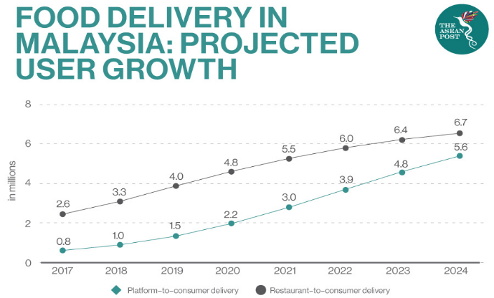*Graph 1: Growth of food delivery in Malaysia*

As technology is advancing, other sectors should also learn to take advantage of this, as underestimating technology can lead to underestimating the potential revenue. Besides, as restaurant mobile apps are classified as hybrid apps, they are faster to develop, are usable across all devices and save time and money. Although they lack the performance and optimization level of a native app, a restaurant mobile app does not have to be very complex, as too much complexity can cause misunderstandings from customers. Besides, these apps only require a few permissions such as access to files and media for ads personalisation and location for online delivery.

Finally, this type of app is suitable for restaurant mobile apps as most restaurants already have a devoted client base and are offering them more by providing a mobile app for extra online services.

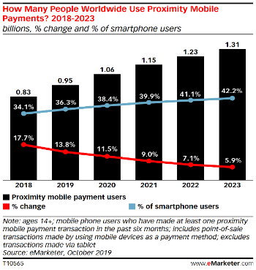

*Graph 2: Mobile Phone users online payment growth chart*

By introducing Artificial intelligence into business data analytics, businesses are able to get cognitive insight. This is where algorithms are used to detect and interpret patterns in massive amounts of data. Artificial intelligent-powered sales are able to identify the items that the customers are most likely to purchase. Thus, it can help a business recognize what to market to their customers and which customers to prioritize. It can also help in automating personalized digital targeted advertising. Besides, document and identity verification can also be done easily with artificial intelligence implemented. This helps businesses avoid getting scammed or hacked. For instance, CAPTCHA tests. Furthermore, artificial intelligence allows cognitive engagement to exist. This allows engagement for customers to occur. Therefore, 24/7 customer service can be provided to aid the customer when facing any issues which at the same time can improve customer experience.

There are realistic applications to these solutions. The application of Artificial intelligence helps in process automation. For instance, implementing robotic process automation technologies. These technologies act like humans and consume information from multiple IT systems. Tasks like transferring customer details can be made by using these technologies which are done by many businesses nowadays.

Standard Operating Procedures (SOPs) is a viable method as it is a step-by-step instruction on how to undergo a task. This helps in increasing productivity while reducing any risk faced. By doing so, restaurant businesses are able to run consistently. This solution should also be easily implemented as almost everyone owns a smartphone. The only downside is the elderly may not be able to adapt. This can be easily solved by having some guidance from their children or grandchildren. In addition, as long as the application is user friendly, the elderly should not have an issue adapting to it. A tutorial or guide should be provided by the restaurant businesses to help ease the customers to adapt to these SOPS. This in turn can also help improve customer experience making this solution absolutely viable.

This solution has a realistic application. This is because the applications required to undergo this process exist and are easily accessible. They can be easily downloaded from play store or app store. Besides, QR codes were developed in 1994 and are not something new. It is something that is utilized by almost every business sector whether you realise it or not.

**6.0 Architecture Overview**

**6.1 System Architecture of the Application**

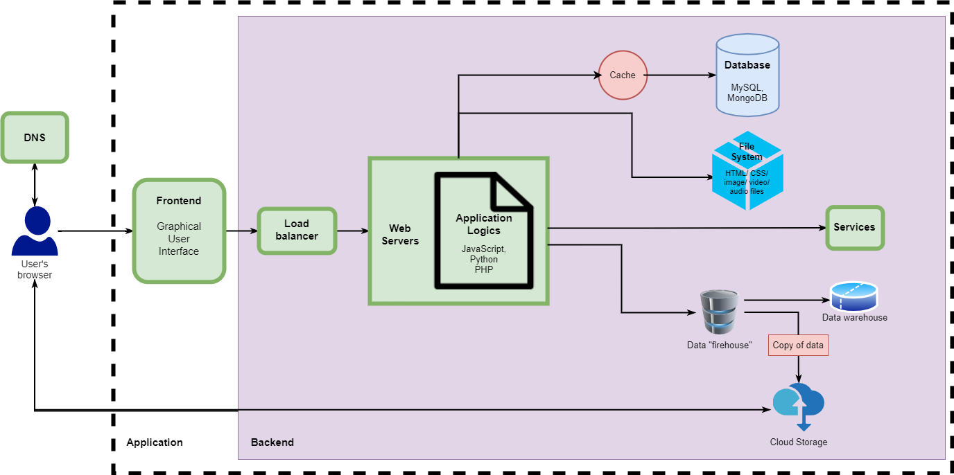

*Diagram 8: System Architecture*

**DNS**

DNS or Domain Name System is a fundamental system that maps the domain name of a website to Internet Protocol (IP) address.

**Frontend**

User interface of web application.

**Load Balancer**

Load Balancer distributes incoming clients’ requests among multiple servers. This is called horizontal scaling and it prevents the servers from overloading.

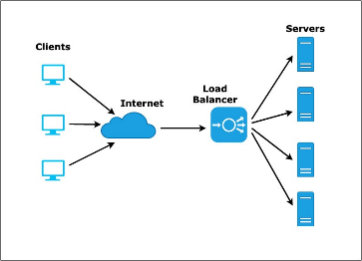

*Diagram 9: Where load balancer uses in*

**Databases**

The database is an organized collection of structured data which is normally stored digitally.

**Cache**

Cache is a temporary storage for data used lately. This enables users to obtain data quicker after using the website for the first time.

**Data Firehose**

Data Firehose provide streaming of real time data for absorption and processing

**Data Warehouse**

Data warehouse is a collection of business data which are analysed to support decision making.

**Cloud Storage**

Cloud storage is a type of cloud computing service which provides data storage.

**Services**

Type of services that our application provides to users.

**7.0 Technologies/ Resources**

**7.1 Technologies, Platforms, and Resources Required to Implement the Solution**

***(Refer to Appendix for further explanation)***

1. **Hypertext Markup Language**

* Language to display documents in web browser

1. **Cascading Style Sheets**

* Language for describing the presentation of web pages

1. **JavaScript**

* Programming language used to develop this project

1. **ReactJS**

* JavaScript library to build user interfaces

1. **NodeJS**

* Backend runtime environment to execute JavaScript codes

1. **Visual Studio Code**

* Code editor used to write code

1. **MySQL**

* Database management system to manage data

1. **Amazon Web Services**

* Provide cloud services such as web hosting and cloud storage

1. **PayPal SDK (Software Development Kits)**

* Used to create payment gateway

1. **Geolocation API (Application Programming Interface)**

* Access users’ location with their consent

1. **Google Data Studio**

* Used to visualize users’ data

1. **Python**

* Programming language used to build artificial intelligence models

1. **Artificial Intelligence**

* Can analyse data and recommend products or advertisement based on users’ preference

**n) PHP**

* Programming language used to develop website

(3071 words)

**8.0 Referencing**

**8.1 Website Materials**

* Batra, B (n.d.), 7 Advantages Of Using A Mobile Ordering App For Your Restaurant, Restolabs, viewed 3 October 2021, <https://www.restolabs.com/blog/7-advantages-using-mobile-ordering-app-your-restaurant>
* Balbier, P. (2019), What is React.js Framework?, netguru, viewed 11 October 2021, <https://www.netguru.com/blog/what-is-react-js>
* Bertschi, S. (2020), The Need for Business Data Analytics Continues to Grow During COVID-19, International Institute of Business Analytics, viewed 6 October 2021, <https://www.iiba.org/business-analysis-blogs/the-need-for-business-data-analytics-continues-to-grow-during-covid-19/>
* CHI Software, (2021), How to Make a Mobile Wallet App in the Digital Money World, CHI Software, viewed 10 October, <https://chisoftware.medium.com/how-to-make-a-mobile-wallet-app-in-the-digital-money-world-cc9b0a00fa4>
* D’Ambra, S (n.d.), How Mobile Apps Are Built, Cleartech Interactive, viewed 2 October 2021, <https://www.cleart.com/how-mobile-apps-are-built.html>
* Davenport, T.H. (2018), Artificial Intelligence for the Real World, Harvard Business Review, viewed 6 October 2021, <https://hbr.org/2018/01/artificial-intelligence-for-the-real-world>
* Deng, I. and Nicholson, G. (2020), Covid-19 has been a ‘roller-coaster ride’ for Asia’s food delivery business, says Foodpanda Asia CEO, The Coronavirus Pandemic, viewed 10 October 2021, <https://www.scmp.com/tech/start-ups/article/3084383/covid-19-has-been-roller-coaster-ride-asias-food-delivery-business?module=perpetual_scroll&pgtype=article&campaign=3084383>
* Deremuk, I. (2021), Modern Web Application Architecture Explained: Components, Best Practices and More, LITSLINK, viewed 11 October 2021, <https://litslink.com/blog/web-application-architecture>
* digital.govt.nz, (2020), *10. Use digital technologies to enhance service delivery*, digital.govt.nz, viewed 1 October 2021, <https://www.digital.govt.nz/standards-and-guidance/digital-service-design-standard/principles/use-digital-technologies-to-enhance-service-delivery/>
* Enberg, J. (2019), Global Mobile Payment Users 2019, Insider Intelligence, viewed 9 October 2021, <https://www.emarketer.com/content/global-mobile-payment-users-2019>
* EY, (2020), COVID-19: Impact on Malaysian businesses, EY, viewed 8 October 2021, <https://www.ey.com/en_my/take-5-business-alert/covid-19-impact-on-malaysian-businesses>
* Four Sea Restaurant, (n.d.), Four Sea Restaurant | authentic Chinese food in Southern California, Four Sea Restaurant, viewed 1 October 2021, <http://www.foursearestaurant.com/about/>
* Gupta, M. (2021), 12 Backend Development Tools For Web Developers, GeeksforGeeks, viewed 12 October 2021, <https://www.geeksforgeeks.org/12-backend-development-tools-for-web-developers/>
* Kaneriya, T. (2021), 12 Best Nodejs Frameworks for Web Apps in 2021, SIMFORM, viewed 11 October 2021, <https://www.simform.com/blog/best-nodejs-frameworks/>
* Kinlan, P. (n.d.), User Location, Web Fundamentals, viewed 11 October 2021, <https://developers.google.com/web/fundamentals/native-hardware/user-location>
* Maze, J. (2020), MOBILE ORDERING TAKES OFF, THANKS TO COVID, Restaurant Business, viewed 3 October 2021, <https://www.restaurantbusinessonline.com/technology/mobile-ordering-takes-thanks-covid>
* Roe, D. (2020), How Data Analytics Are Gaining Ground During COVID-19, CMS Wire, viewed 5 October 2021, <https://www.cmswire.com/information-management/how-data-analytics-are-gaining-ground-during-covid-19/>
* The App Solutions (n.d.), REASONS TO GIVE UP ON UBEREATS AND BUILD A RESTAURANT MOBILE APP, The App Solutions,<https://theappsolutions.com/blog/development/mobile-app-for-restaurant/>
* The ASEAN Post Team, (2020), Safe Food Delivery In Malaysia, viewed 9 October 2021, <https://theaseanpost.com/article/safe-food-delivery-malaysia>
* Vikneswaran, (2020), Load Balancers, An Analogy, codeburst.io, viewed 9 October 2021, <https://codeburst.io/load-balancers-an-analogy-cc64d9430db0>
* Voicu, L. (2020), The 13 Worst Restaurant Problems and Solutions to Each of Them, Gloria Food, viewed 10 October 2021, <https://www.gloriafood.com/restaurant-problems-and-solutions#online>
* Web Application Architecture - Load Balancing and Caching (2018) Youtube Video, added by CodeLit [Online]. Available at <https://www.youtube.com/watch?v=U9P96XQ2688> [Accessed 12 October 2021]
* Yunus, R. (2020), Covid-19 continues to fuel e-wallet, The Malaysian Reserve, viewed 13 October 2021, <https://themalaysianreserve.com/2020/11/30/covid-19-continues-to-fuel-e-wallet/>
* PixelProArts, (n.d.), Customize this Retail Poster Template, postermywall, viewed 14 October 2021, <https://www.postermywall.com/index.php/art/template/81fc8bb176f31490141e5f52f0838686/no-dine-in-covid-19-delivery-poster-sign-design-template#.YWcHYxozZPZ>
* Home Food Review (2021), Senarai Khidmat Delivery Makan Di Malaysia, BELANGTARUNG LIFESTYLE, viewed 14 October 2021, <https://www.belangtarung.com/2019/08/senarai-khidmat-delivery-makanan-di.html>

**8.2 Books**

# Richards, M. (2015), Software Architecture Patterns, 2nd ed. Sebastopol: O’Reilly

* Robbins, J.N. (2018), Learning Web Design - A Beginner’s Guide to HTML, CSS, JavaScript, and Web Graphics, 5th ed. Sebastopol: O’Reilly Media
* Gerner, M. (2020), Using AI to cope in the coronavirus era, Raconteur, <https://www.raconteur.net/technology/artificial-intelligence/covid-19-ai-solutions/>

**8.3 Journal Article**

* Huang, X. and Huang, Y. (2015), A Research on the Difficulties and Countermeasures of the Traditional Business under the Background of Mobile Internet, *Open Journal of Business and Management*, vol. 9, no. 5, 441-445.
* Verma, P. (2020), The effect of presentation, product availability and ease upon transaction reliability for online food delivery aggregator applications – moderated mediated model, [*Journal of Foodservice Business Research,*](https://www.tandfonline.com/toc/wfbr20/current) vol. 23, no. 4, pp. 285-304
* Whitelaw, S. and et al. (2020), Applications of digital technology in COVID-19 pandemic planning and response, *The Lancet Digital Health,* vol. 2, no. 8, pp. 435-440

**9.0 Appendix**

The code editor we are going to use for this project is Visual Studio Code. For the frontend, we are going to start off by using Hypertext Markup Language (HTML) and Cascading Styling Sheet (CSS). HTML is a language to display documents in a web browser while CSS is a language for describing the presentation of web pages, including font, colour and layout. We are also using JavaScript programming language to develop this project. ReactJS, a JavaScript library, is also used to build the user interface.

For the backend, we are using NodeJS, a backend runtime environment to execute JavaScript codes. We are also using MySQL, an open-source database management system to manage our data. Cloud computing services such as Amazon Web Services’ (AWS) is used for web hosting and cloud storage. Cloud computing is the delivery of computing services—including servers, storage, databases, etc. Furthermore, PayPal SDK (Software Development Kits) is used to create payment gateway. As we are doing a delivery application, we will also use geolocation API (Application programming Interface) to access users’ location with their consent.

Other than that, we will build a dashboard using Google Data Studio for the restaurant owners to analyse users’ data. Python programming language is used to build artificial intelligence model which are the backbone of our recommendation system of restaurant’s product and advertisements. Artificial Intelligence is the simulation of human intelligence processes by machine.